The Fundamentals - Setting Up our Database Filemaker Pro 5.0

When you finish this training on the fundamentals, you will have created a database solution consisting of a linear database and possibly one relational database all working together to create a customers database.

Later you will learn relationships, look-ups, calculations, scripting, drop-down lists, summary fields, summary reports, portals, file sharing, networking and more.

1. First we'll create a database. A database is a file. Within your new file you will have individual records that each contain different fields for storing different information.
like- first name, last name, address etc.

- Start Filemaker Pro 5
- Click on Create a new empty file
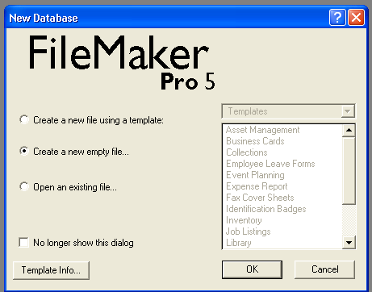

- Save as customers to your AIT Task 1 folder.

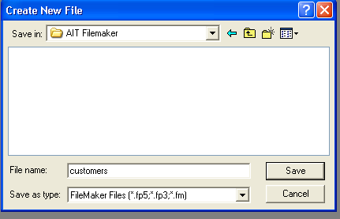

Filemaker Pro 5 Window ready to enter fields

After saving your filename "customers.fp5" you will see the field definitions window below

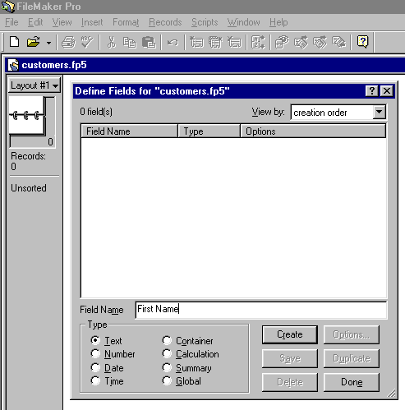

. Lets create all the fields we will

- Create all the files we will need now.
Type in "First Name" leave the radio button below it set to "Text" and click on create.
Now repeat the process for
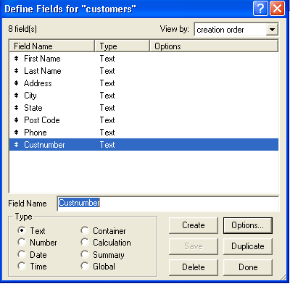
"Last Name",
"Address",
"City",
"State",
"Post code",
"Phone"
All these should be Text fields.

Now enter a field that will be our key or primary key.

"Custnumber".

We now need a unique field for
custnumber field
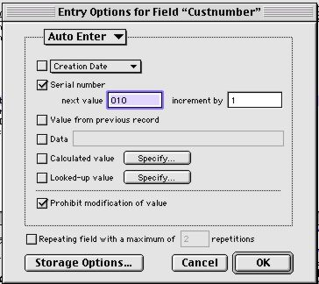
- From the File menu open
- Define Fields and click on field
- Custnumber

- Click on the Options button
- This will take us to this Window

- Click Serial Number and set
- The number to 001

- Click Prohibit modification
- of value

- Click OK

- Then click "Done"

You will now see the database in basic entry mode.

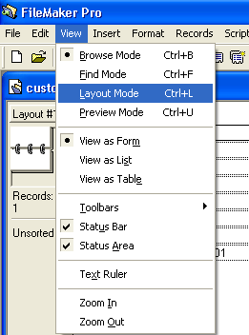
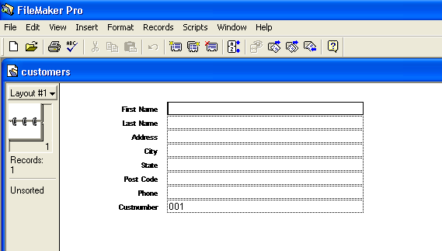

Let us change the layout name from Layout#1 to Customers

Go to View menu

and to Layouts - Layout Setup…
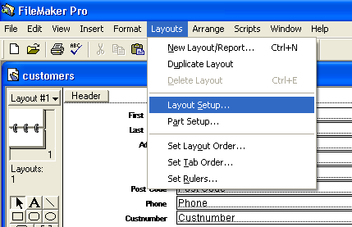

Replace Layout#1 with Customers in the Layout Name box

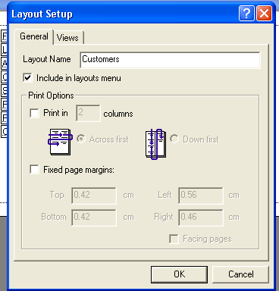
Ensure Include in layouts menu is ticked

Click OK

Now we need to edit our layout in Layout mode click on View and show Toolbars Text Formatting, Tools and Arrange toolbars.

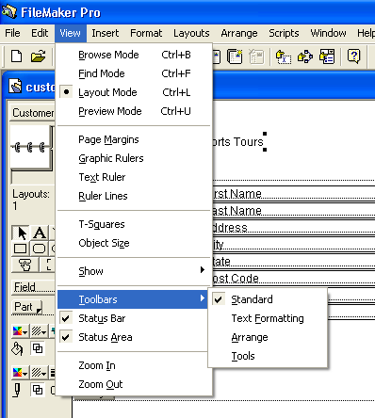
You can now alter the placement of your database add colours to fields and add buttons

Play with your design and create a unique database for your company

Next we will import some data and add our new customers

This ends this session

Prepared by Peter J Faulks

